Community Payback Orders

Background
The Scottish Government introduced Community Payback Orders (CPO) in February 2011. Replacing several community disposals and to reduce short prison sentences of 3 months or less to focus on community alternatives, short sentences may still be imposed by the court however this is under exceptional circumstances.

A CPO may consist of one or more of nine requirements
- Unpaid work
- Offender supervision
- Compensation requirement
- Programme requirement
- Residence requirement
- Mental health treatment requirement
- Drug treatment requirement
- Alcohol treatment requirement
- Conduct requirement

Unpaid work
Unpaid work requirements are imposed for a period between 20-300 hours. Hours from 20-100 are referred to as level 1 hours to be completed within 3 months and between 101-300 regarded as level 2 and completed within 6 months.

Activities may vary for unpaid work parties can vary; some activities may include:
- Gardening, landscaping
- Painting
- Construction
- Recycling
- Refurbishing furniture

Unpaid work activity requests come from members of the public and each local area will have their arrangements for dealing with requests.
Unpaid work is used to benefit the community as it enables individuals to:
- learn new skills
- increase self-esteem
- improved work prospects
- learning to work as part of a team

Personal Placements
Personal placements provide an opportunity for individuals to develop new skills and support local communities
There is a strong focus within personal placements for individuals to learn and develop new skills as this can contribute to sustaining future employment opportunities which is a vital
factor in reducing reoffending. There may be opportunities for individuals to volunteer for organisations they have completed their unpaid work hours.

Time
Each individual will have their set number of hours they need to complete, normally ranging from 100 – 300 hours (300 maximum).
- Some individuals may have started their ours as part of a group before beginning their personal placement, therefore will do slightly less than their sentenced hours.
- This can be due to getting to know the individual and identify and appropriate alternative to working within a group.

Risk
The risk will vary by individual and by workplace setting

- Each setting will be visited and assessed by social work before setting up placements.
- Each individual will be assessed before nominating them for personal placement.
- Placements should be chosen appropriately to suit the individual and the placement provider.
- Regular contact is made between social work and the placement to ensure there are no issues and if any issues are identified early and managed.

Employee Protection

- The placement provider becomes responsible for the health and safety of individuals undertaking a personal placement, the same way they would for paid employees and volunteers.
- Employee protection is considered by social work when the initial risk assessment before set up of personal placements.

Contact Details
For more information on personal placements

Ann MacDonald
Team Leader
Fast Track Team
80 Norfolk Street
Glasgow
G5 9EJ

Office No: 0141 274 6000
Email: Ann.Macdonald@glasgow.gov.uk

For further information contact Community Justice Glasgow:

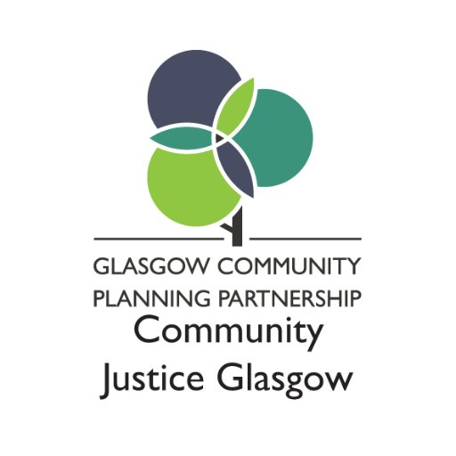
Telephone: 0141 287 0916

E-Mail: CommunityJustice@glasgow.gov.uk

Twitter: @CJusticeGlasgow

Address: CSG Eastgate
727 London Road
Glasgow
G40 3

