Barlinnie Throughcare Working Group

Background

The Throughcare Group was initially set up in 2012 to ‘support people going out the door’. In 2013 the group was reviewed and formed the Barlinnie Throughcare Strategy Group with a themed focus. Themes explored in detail to date have included Housing and Employability.

With a clear action plan attached to both themes, successes and areas for continued development have been reported through CJA Annual Reporting mechanism.

The Throughcare Strategy Group consisted of 30+ members from a range of public and 3rd sector organisations. Representation from group members ranged from practitioner to strategic levels of input. Meetings also provided the opportunity for partners to share information and provide updates.

Context
A New Model for Community Justice
The Community Justice (Scotland) Act was passed in February 2016 and came into effect on April 2017. The act focussed on local delivery of community justice services, and so rather than 8 Community Justice Authorities coordinating this across Scotland, a named set of community justice partners in each local authority area would be responsible for Community Justice, further engaging other bodies that local partnership wish to involve. In addition to the revised local arrangements, a new body, Community Justice Scotland, was also formed to provide a central role in continuing to improve Scotland’s justice system. In Glasgow, Community Justice Glasgow has been established and has responsibility for the day to day planning and service delivery.

In line with the statutory requirements, Community Justice Glasgow has published its Community Justice Outcomes Improvement Plan (CJOIP), for the year 2017/18. This plan outlines nine local priorities for Glasgow. These priorities are all connected and interlinked; however, 5 can be identified as the most directly relatable to Throughcare:

- Service User Voice – We will ensure that individuals who access services are at the heart of service planning and delivery.
- Service and Resource Alignment – We will use resources where they are most effective, and in a collaborative approach to improve outcomes.
- Building Protective Factors – We will improve factors evidenced to influence re-offending, including employability, education, health and well-being and housing.
- Families – We will ensure new developments reflect the impact on the family, and build on the resilience opportunities of a supportive family setting.
- Throughcare – We will improve the planning for people leaving custody, to support the return to the community from prison.

Remit of the Group

A development session was held in February 2017 to review the function and form of the Barlinnie Throughcare Group, which was attended by a wide range of stakeholders who provided their views on the future remit. The following was agreed:

- The focus for the group going forward should be on those incarcerated in Barlinnie returning to a Glasgow postcode area.

- The group should function as an implementation group, influencing strategy and policy decision, which would be reflected in its membership.

- The agenda should focus on 7 key areas of activity:
  - Service User Input
  - Communication
  - Learning & Development
  - Action Planning and performance management
  - Advocacy (policy and practice)
  - Positively challenging reality
  - Implementation

- Membership should reflect the decision making function of the group. Members would be chosen form the following identified at that development session, although some organisations would attend when the agenda required, rather than all meetings:
  - Police partnerships “G” Division.
  - Third Sector/Partners/Middle Management level.
  - Statutory Services including;
    - Department of Work & Pensions
    - Local Authority Criminal Justice / Homelessness Social Work Services; and
    - Prison Healthcare.
  - Business and commerce.
  - Larger community based groups.
  - SPS – Head of Offender Outcomes HMP Barlinnie.
  - Addiction Services (Prison Locality).
  - Glasgow West of Scotland Housing Forum.
  - Other Local Authorities.
  - Service Users.
  - Named Community Justice Partners.
  - Visitors/strategic/Policy Leads.

Accountability

The Group will report to the Community Justice Transition Working Group initially; however this will be discussed with the group and may change as wider governance arrangements become clearer in community justice generally within Glasgow city. Initially, the group will report to the Transition Working Group, share minutes and its action plan, and report on progress towards meeting its actions. Papers produced by this working group will inform the Transition Working Group, influencing strategy and policy decisions. This is the action plan implemented by the CJA, and will be revised by the working group on an ongoing basis.

Meetings

Meetings will take place quarterly initially, however this will be discussed with the wider group, and ensure that this will meet the requirements of the Action Plan for the group. Venue will also be discussed with the group and agreed at its first meeting following the development session.

Review

A review of the new Community Justice arrangements will be initialized by the end of 2017, and part of this review will include the function and form of its working groups, including the Barlinnie Throughcare Working Group.

Communication and Engagement

Wider communication and engagement will initially be managed by the Transition Working Group, as part of CJG’s developing communication and engagement strategies. This will also be discussed with the Barlinnie Throughcare Group, to ensure these strategies reflect activity of this group.

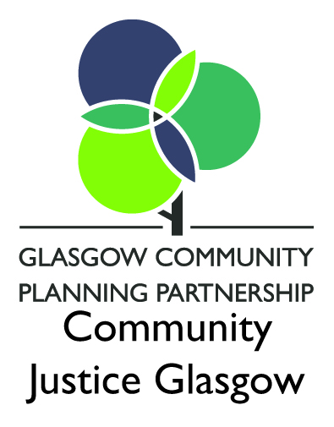

Contact us -
Telephone: 0141 287 0916
E-Mail: CommunityJustice@glasgow.gov.uk
Twitter: @CJusticeGlasgow
Address: CSG Eastgate
727 London Road
Glasgow
G40 3AQ

